**Asian School of Management and Technology**

(Affiliated to Tribhuvan University)

Gongabu, Kathmandu

**Full Marks: 60**

**Time: 3 Hrs.**

**SET A**

**Preboard Examination 2080**

**BIM / Fourth Semester / IT 240: Business Data Communication and Networking**

***Candidates are required to answer the question in their own words as far as practicable.***

**Group A**

**Brief Answer Questions [10x1=10]**

1. What is the multicast address of the RIPv2, EIGRP and OSPF?
2. What is the function of NAT?
3. What is the Default Gateway?
4. What is IP Address?
5. How to check the source to destination reachability?
6. How to check routing table?
7. What is the different between HTTP and HTTPS?
8. What is Autonomous System Number?
9. Define the unicast, broadcast, and multicast?
10. Write down the port no below protocols.

a. HTTPs b. Telnet c. SMTP d. DNS

**Group B**

**Short Answer Question [5x3=15]**

1. Explain the three-way handshake rule.
2. Define the terms: Bandwidth and latency?
3. Different between Connection Less and Connection-Oriented Service?
4. **C**
5. **C**
6. **C**

**Group C**

**Long Answer Questions [5x4=20]**

1. Sdsd
2. Df
3. Dfd
4. From the following topology diagram find the shortest path from Router 2 (R2) to all other Routers in the tabulated form.

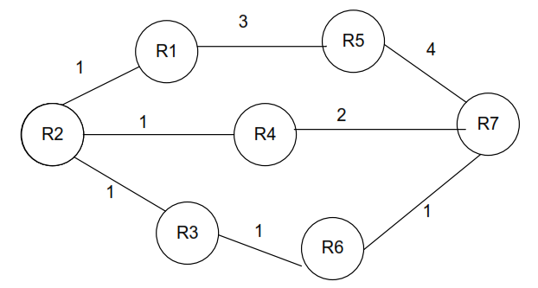

**Group D**

**Comprehensive Question: [2x5=10]**

1. Draw the logical topology with the technical documentation.

A newly established college is opening soon with three new departments A, B, C, and two labs. The IPv4 address prefix of the new college LAN is 192.168.10.0/24 and it is

Expect each department to have the following number of hosts:

Admin: 10 hosts

Account: 5 hosts

Library: 25 hosts

LAB-1: 30 hosts

LAB-2: 30 hosts

1. Define is the protocol. Compare the OSI Reference Model with TCP IP and explain in detail.